Summary of the Draft
National Programme for Rural Areas
November 2023

1. Foreword
This is a summary of the Draft National Programme for Rural Areas (NPLG). The Draft NPLG is an important document that assists provinces and other stakeholders in taking steps towards sustainable rural areas. This abbreviated version of the Draft NPLG is intended for a broad interested audience. Between 12 December 2023 and 22 January 2024, anyone is welcome to submit an official response to the Draft NPLG. The provinces have already made a vigorous start with their own area programmes. The full version of the Draft NPLG is the only legally valid version.
Contents
2 Inleiding 5
Juridisch kader NPLG 5
Samenhang met andere Rijksprogramma’s 5
3. Doelen 7
Natuur 8
Water en bodem 8
Broeikasgassen landbouw en landbouwgebruik 8
Groenblauwe-dooradering 8
Samenhang in doelen 8
4. Structurerende keuzes 9
Omgevingskwaliteit als verbindend principe 11
Uitwerking structurerende keuzes 11
Meekoppelende structurerende keuzes: Meewegen dier- en volksgezondheid in gebiedsprogramma’s 11
Omgaan met schaarse ruimte 11
Wetgevingsagenda 12
Adviezen uit het maatschappelijk middenveld 12
5. Programmatisch, cyclisch en adaptief werken 14
Sturingsfilosofie 14
NPLG Cyclus 14
Inzicht in de voortgang van de uitvoering van het NPLG en de PPLG’s 14
Lerende aanpak 15
Bijsturing als de voortgang niet voldoende blijkt te zijn 15
6. Gezamenlijk de doelen realiseren 17
Generiek en gebiedsgericht 17
Instrumentenkoffer 17
7. Participatie en PlanMER 18
Participatie 18
PlanMer 18
Afkortingenlijst 19

1. Introduction

The Draft National Programme for Rural Areas (NPLG) represents the next step towards a sustainable future for rural areas. It provides clarity to provinces and other stakeholders about the steps that need to be taken. It represents a solid foundation for the approach over the coming years. It also provides an insight into the instruments available to provinces for achieving their objectives. The NPLG also discusses the limited physical space in the Netherlands, and the fact that not everything is possible, everywhere.

The balance has been lost
Both nationally and locally we are faced with a series of challenges. Climate change is causing flooding, drought, the salinisation of drinking water, biodiversity decline, health risks and increased uncertainty about the harvests from horticulture and arable farming. There is also pressure on nature, for example due to high levels of nitrogen, drought, increased recreation, acidification of the soil and poor water quality. All this while we are in fact dependent on nature, water and agriculture for health and food. The balance has been lost.

Towards a sustainable future
For all of these reasons, we must find a way to achieve a sustainable future for rural areas. A future in which water quality is in good order, plants and animals can continue to exist and rural areas contribute to tackling and managing climate change. This also includes space for agricultural businesses with sustainable earning models. This transition in rural areas is essential, but is also of considerable relevance for the people who live, work and spend their leisure time in rural areas. For that reason, the NPLG follows a careful approach according to which we can together gradually work towards a sustainable future, in an effective manner, based on an ongoing learning process.

Coherent, area-specific and futureproof
The NPLG approach is coherent, area-specific and futureproof:
- Coherent: The NPLG considers water, nature and climate in careful conjunction. Among others, because this makes it possible to take the necessary steps in a combined approach. For example, this means businesses are not required to first deal with nitrogen (nature) and then start again from the beginning with climate.
- Area-specific: The provinces will draw up area programmes in which they make specific regional plans for the policy principles of the NPLG. With broad-based involvement from the region, they will identify the most appropriate choices.
- Futureproof: The NPLG is focused on the medium term. It does of course take account of the long-term challenges (2050) as well as identifying what those challenges mean for the choices we make today. This will prevent a choice we make now having a negative impact on choices for 2050.

Relationship with other national programmes
The NPLG is a policy programme under the National Strategy on Spatial Planning and the Environment (NOVI) with as its commissioning party three ministries: Agriculture, Nature and Food Quality (LNV), Infrastructure and Water Management (I&W) and the Interior and Kingdom Relations (BKZ). In other words, the NPLG is not a standalone programme but relates closely to various other national programmes. These can be subdivided into the following four sets:
- The spatial framework: NOVI, NOVEX and the new Policy Memorandum on Space (Nota Ruimte).
- The immediate neighbours: programmes and policy that come together in provincial area elaborations.
- More attractive and better: support programmes that supply knowledge, design capacity and assistance.
- Good friends: programmes that impact on rural areas but that are positioned slightly further from the NPLG.
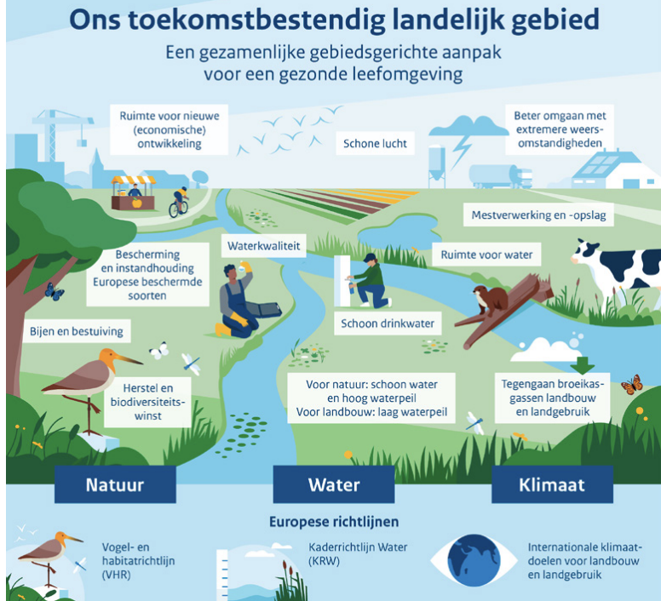

Structure of the Draft NPLG
The Draft NPLG has a logical structure, and that same structure is followed in this summary. Chapter 2 deals with the objectives for fulfilling the ambition of a sustainable future for rural areas. In chapter 3, additional tools are provided in the form of structuring choices. These choices (including spatial choices) describe the process of how we approach the objectives. Chapter 4 describes the means of managing this extensive transition. Chapter 5 deals in more detail with the cooperation between the various government authorities and the Coordination Body for the Transition of Rural Areas. This chapter also describes the instruments available to local government authorities in the ‘instrument case’ that will help realise the area programmes. In conclusion, chapter 6 deals with participation: a transition that has such impact can only succeed if all stakeholders are included in the process.

2. Objectives
Bringing land use back into balance with what the environment needs. This is the primary task for the area programmes. For this purpose, national objectives in the field of nature, water and climate have been broken down to a regional scale. The objectives are based on national and international obligations.
The Draft NPLG explains each of the national objectives. The majority of objectives are distributed across the provinces so that they are more manageable in scale, and can be tackled according to a coherent approach. Realising those objectives is considered essential and consequently unavoidable if we are to re-establish the balance between land use and the limits of the natural systems. For example the emissions of nitrogen, greenhouse gases and the leaching of harmful substances into the water and soil must be restricted. More space is needed for trees, forests and nature.

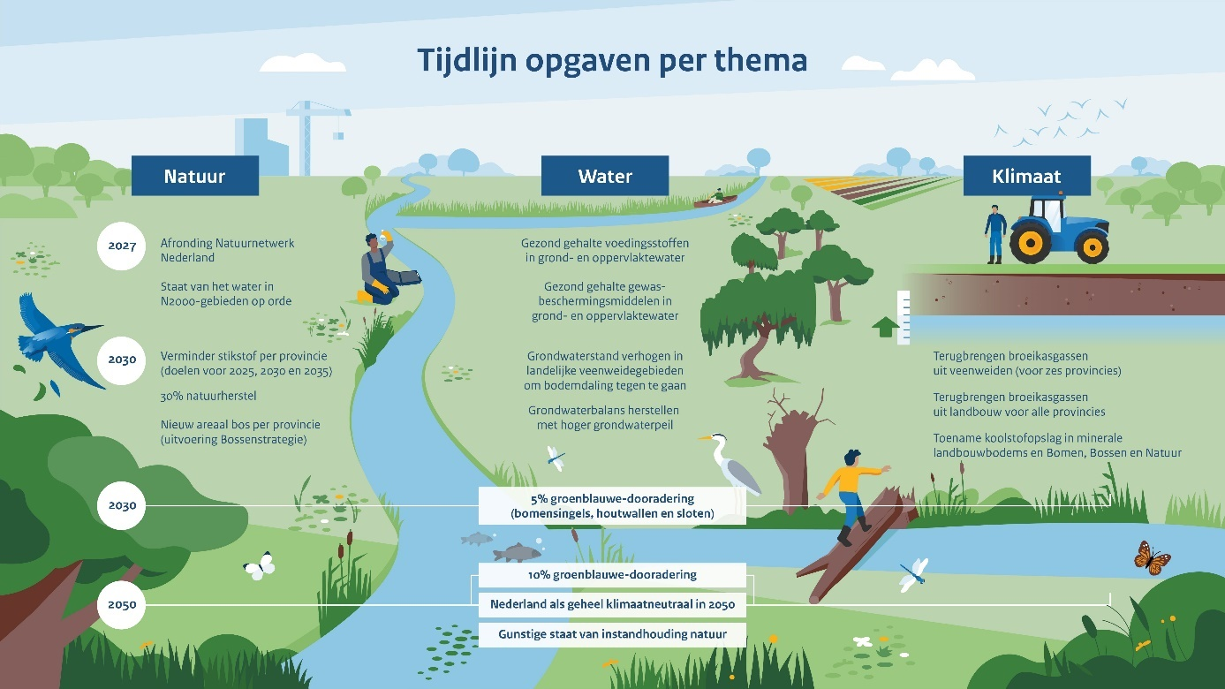

Nature
In respect of nature, the NPLG is focused on implementing the existing European agreements on the conservation and recovery of biodiversity. The objectives of the Birds and Habitats Directive are the central focus. The core task is to re-establish the favourable status of designated bird species and animal and plant species, in the longer term. The task for 2030 is to reduce the gap between that favourable status and the current status by 30%. This will require efforts in a number of areas: for example improved hydrological conditions, less nitrogen and more space for forests and nature. Specific targets have also been formulated for these elements, and distributed across the provinces.

Water and soil
Due to climate change and intensive land use, we are increasingly coming up against the limits of the capacity of the water and soil system. We are not yet sufficiently able to recover water quality. Soil subsidence, salinisation, flooding and desiccation are increasingly problematic. Together, this is one of the causes of the deterioration of nature quality. Agriculture and horticulture are also suffering as a consequence. Our aim is to adapt the policy, the structuring and the management of the water system to the changing climate, with a view to limiting harm and disruption due to extreme weather, as far as possible. Specifically in terms of water quality and the availability of groundwater, we are bound by the obligations contained in the European Water Framework Directive (WFD). At the latest by 2027, all measures must have been taken in the Netherlands that are necessary to arrive at good ecological and chemical quality of groundwater and bodies of surface water.

Greenhouse gases in agriculture and land use
It has been agreed in the Netherlands that all sectors of society must contribute to the national climate target for 2030: 55% emission reduction of greenhouse gases (compared with 1990). To guarantee achieving this objective, government policy is focused on 60% reduction by 2030. Indicative residual emission targets have been agreed for each economic sector, for 2030. The NPLG elaborates the emission reduction targets for agriculture and land use. This target for 2030 means that beyond 2030, the Netherlands and its rural areas will continue to face a major task. Measures aimed at reducing the emission of greenhouse gases will also remain necessary beyond 2030.

Green-blue networking
The NPLG also sets targets for strengthening the green-blue networking of the landscape. This relates to small nature elements that are important in structuring our landscape. They form a network that comprises individual woody elements such as tree-lined avenues, rows of trees, hedges, osier plantations and meadow orchards, non-woody growth such as herb-rich field margins and brushland, and wet elements such as ecologically managed ditches, nature-friendly riverbanks and pools. Green-blue networking supports the other NPLG objectives for nature, water and climate. The ambition is to achieve 10% green-blue networking in rural areas by 2050 (excluding Nature Network Netherlands (NNN), but including land with no agricultural function). A proportion of these structures is already present. The ambition is to have made up half of the shortfall between now and 2050, by 2030.

Coherent targets
The deliberate choice has been made to tackle these targets in a coherent approach. It is socially unacceptable to first call upon farmers to deal with nitrogen, then with water quality and only then to tackle the climate tasks. We must prevent situations occurring in which, for example, a livestock farmer is bought out and stops livestock farming only to start planting bulbs at a location where this is not possible due to the water quality. The tasks are closely interrelated: a nature conservation area in which the hydrology is sound, is better resistant to nitrogen. And if the soil fertility is improved, this also has a positive impact on water and climate.

Provicial distribution of objectives
For their implementation and realisation, a proportion of the national objectives has been regionally distributed. Emission reduction tasks and hectare tasks in the NPLG have been translated to provincial level. This makes the tasks more specific and combines them with other choices to be made in the area. There are also objectives that are not regionally distributed. These include green-blue networking, targets from the WFD and qualitative targets such as those for climate adaptation. By way of example, the regional objectives for the province of Flevoland have been placed in a table.
Flevoland
Nature
Birds and Habitats Directive areas | 2030 | Additional nature task: 59 hectares
 | 2030 | 30% additional agricultural nature: 1,600 hectares
Nitrogen emission reduction | 2035 | Emission reduction (livestock accommodation and fields) nitrogen of 442 (tonnes NH3). This equates to a 24% reduction in nitrogen emissions.
NNN and Forest Strategy | 2027 | Remaining task for new nature according to NNN of 105 hectares
Forest strategy | 2030 | Expansion of forests by 664 hectares. To be divided into 64 hectares according to NNN, 600 hectares outside NNN and 0 hectares compensation.
Climate
Land use - mineral agricultural soils | 2030 | Regional carbon capture in mineral agricultural soils of 0.061 Mtonne CO₂ eq. (over and above basic pathway for Climate and Energy Outlook 2021) eq.
Land use - peatland |  | n/a
Agriculture | 2030 | Regional emission reduction challenge greenhouse gases for livestock farming and manure application in arable farming of 0.1 Mtonne CO₂ eq.

3. Structuring choices
Merely identifying objectives provides insufficient opportunities for the transition of rural areas. For that reason, the NPLG works with a set of structuring choices. These choices (including spatial choices) describe how the programme will work towards achieving the objectives. They relate to the themes nature, water and soil and agriculture. There is, for example, a structuring choice that calls for the designation of transition areas around Natura 2000 areas. And a structuring choice about carefully dealing with land in use for agriculture. The choices will set the course for the area processes. This chapter considers the question how the already scarce space should be managed.

What are structuring choices in the NPLG?
Structuring choices within the NPLG are choices made by national government regarding the use of space. The choices in the NPLG take the form of general structuring principles that consider the desirability or undesirability of new and existing activities in rural areas. By means of the structuring choices, the NPLG sets a course for the spatial elaboration of the area programmes by the provinces.

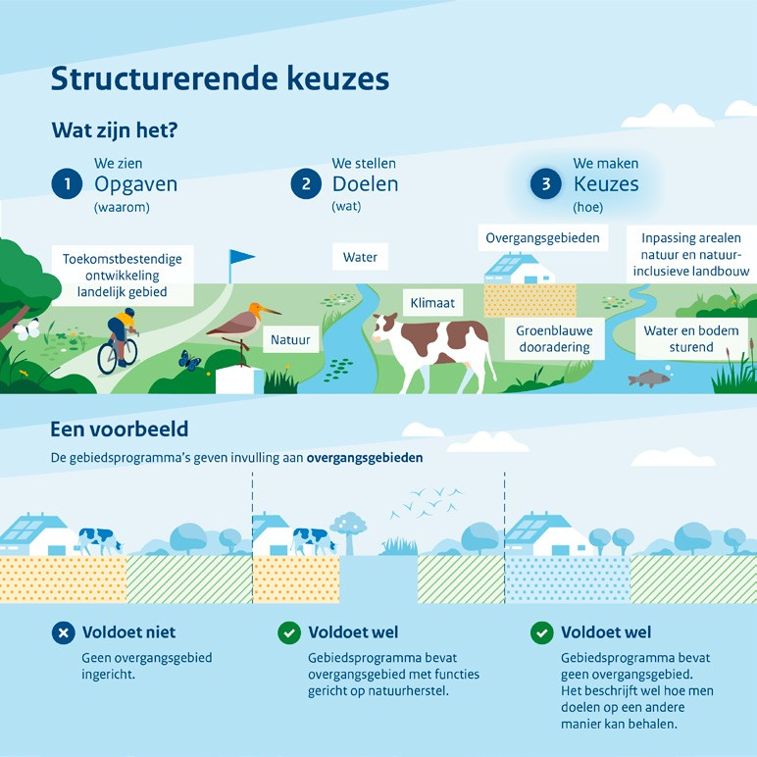
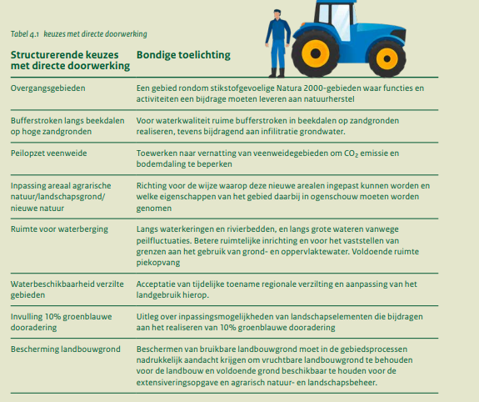

Environmental quality as a binding principle
Working on environmental quality will benefit the coherent and area-specific approach of the NPLG. Environmental quality takes the existing landscape as its starting point and places a central focus on the value and meaning of a location for current and future users. As such, working on environmental quality thereby goes beyond the various different tasks in an area. It places sectoral tasks in a coherent structure and combines them with the features of the water and soil system and the landscape features of the area. An area-specific dialogue about the intended environmental quality contributes to support for change within society.

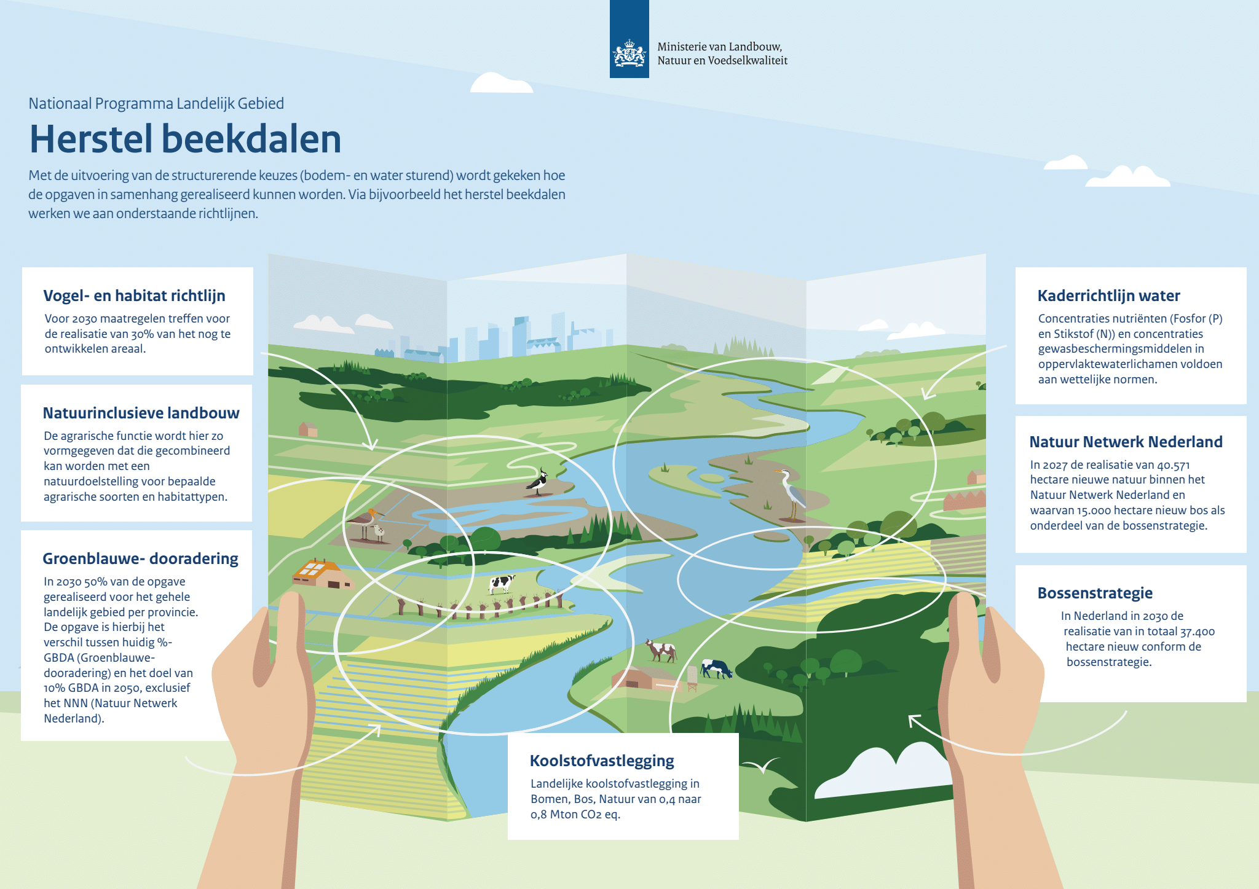
National government is now encouraging the embedding of the structuring choices in provincial area programmes with financial resources, as well as reaching administrative agreements on these issues. As the iterative NPLG continues to develop, it may emerge that other tools will have to be deployed in applying the structuring choices, from the point of view of achieving objectives, spatial coherence and unavoidability. With that in mind, in consultation with provinces and other stakeholders, national government will continue to assess whether changes need to be made to the regulations. This could, for example, make it possible to focus more attention on the application of effective and urgent structuring choices.

Advice from civil society
In developing policy on the structuring choices from the NPLG, the ideas and proposals from civil society organisations involved in the transition have played an important role. The structuring choices have not emerged within national government in isolation, but build upon and tie in with perspectives and solutions put forward by society.
A number of structuring choices, including the choices transition areas and achieving green-blue networking, were developed in close consultation with civil society actors. A number of civil society organisations for example initiated the working group transition areas, for consultation with national and provincial government about how transition areas around Natura 2000 areas could be deployed to facilitate system recovery in these areas and to offer a perspective for agriculture. The working group is an important platform for the development of these areas. Advice from the working group was included in the development of the structuring choices in the NPLG.
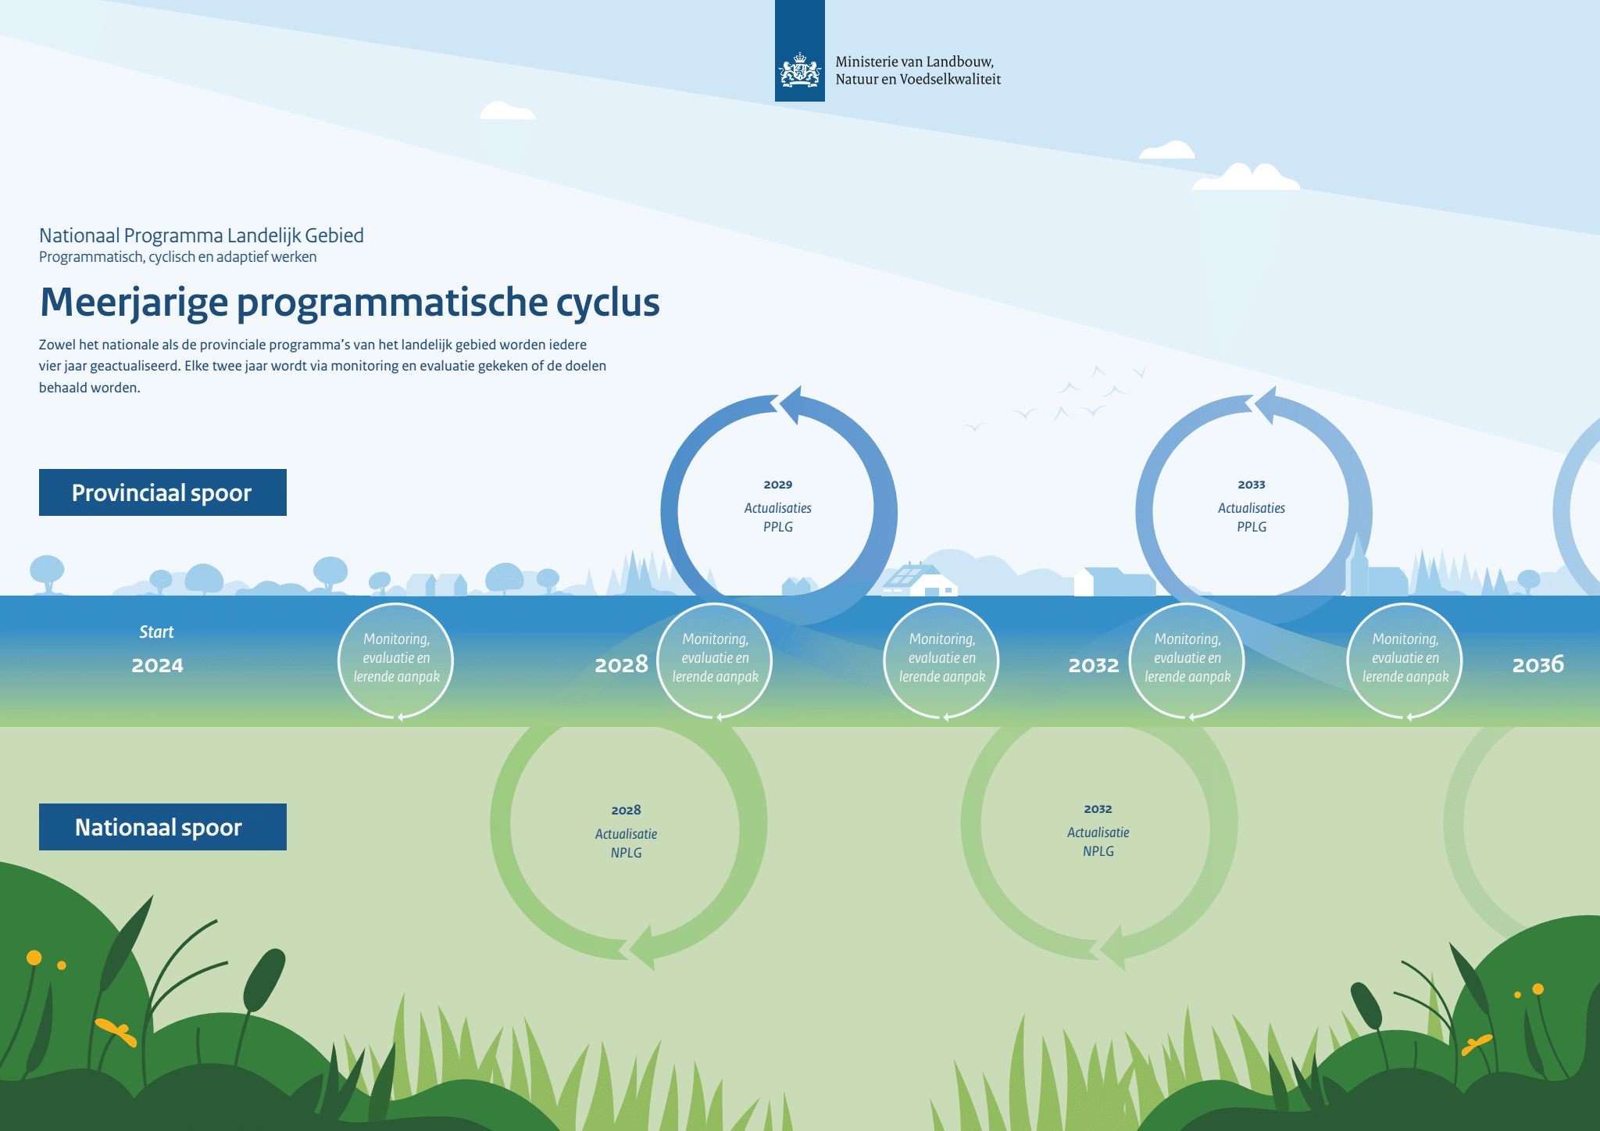

4. Programme-based, cyclic and adaptive work processes
The far-reaching transition of rural areas calls for a solid management philosophy. This is the foundation for predictability and helps secure the permanent availability of support. In line with this philosophy, the NPLG works according to a programme-based, cyclic and adaptive approach. The various levels of government are working towards the transition according to a 4-year cycle. Within that cycle, the NPLG is updated every four years. The same applies to area programmes, but each time one year after the NPLG.

Management philosophy
Not everything has to be done at once. The management philosophy behind the NPLG and the provincial area programmes is specifically aimed at working together on a programme-based, cyclic and adaptive approach. For the coming years, this will be the common guideline for the transition of rural areas. The responsibilities will be shared across a broad range of parties. For that reason, it is essential that the management philosophy be concretised, and a rhythm agreed upon for fine tuning and updating.

NPLG Cycle
In practice, the chosen management philosophy creates a 4-year cycle for the updating of the NPLG (see figure 5.1). This cycle offers sufficient solid ground to allow work to be carried out on the transition of rural areas according to a fixed rhythm for several years. The first cycle will start following the adoption of the NPLG. Various approaches will be employed to ensure that the cycle can be successfully implemented, while never getting in the way of actual execution. For example a monitoring and evaluation system, a description of the assessment process and explanatory notes to the learning approach.

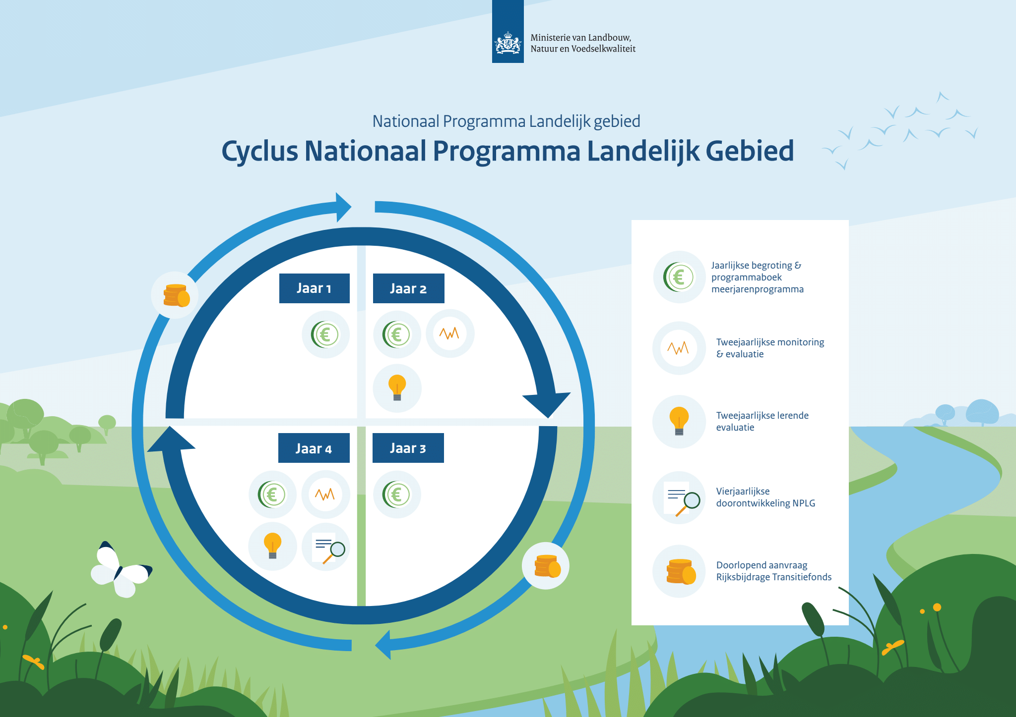

Insight into progress in execution
The four primary tasks of the NPLG combine to achieve a multiyear sustainable transition in rural areas. This essentially requires a regular insight into progress on the NPLG objectives and the broader impact. This is also needed to be able to account for the approach and the spending of resources. Furthermore, it can contribute to inter-administrative learning, but on its own is insufficient for that goal. For that reason, in addition to monitoring the progress of execution and the realisation of the objectives, a separate learning approach has been elaborated within the NPLG.
A number of instruments and reports have been developed for accounting, aimed in broad terms at the following three objectives:
- insight into the relationship between the individual provincial area programmes by assessment of the PPLGs
- insight into the progress of the measures via the Multiyear programme Transition Fund Rural areas and nature
- insight into the achievement of the NPLG objectives via monitoring and evaluation in a biannual NPLG outlook.

Fine tuning if progress proves insufficient
The government has opted for an approach that guarantees that the primary objectives in nature, water and climate are unavoidably realised. Realisation of the approach is essential to bring about nature recovery, to improve water quality and to fulfil the climate task. Unavoidable achievement of objectives calls for appropriate fine tuning if progress proves insufficient.
In the NPLG cycle described for this purpose and in the area programmes, fine tuning is possible at any moment. Over the coming years, the monitoring system will play an important role in determining whether the approach is on course for achieving the objectives. For the monitoring of measures, use will be made, for example, of the multiyear programme with a Programme Book that must be updated each year, and presented to the Dutch House of Representatives with the budget for the Transition Fund.

Learning approach
The NPLG and the area programmes have an adaptive character: they offer sufficient space to take the first step, and then to ensure continuous improvement as the level of understanding improves. It is essential in this process that both national government and local and regional authorities remain open to bottlenecks and opportunities that arise in the practical implementation process, and that could result in adjustment of the policy frameworks. This, in turn, essentially calls for the organisation of systematic, continuous and inter-administrative learning. At the same time, it calls for the active gathering of new insights and experience from the field and from research, reflection, evaluation and adaptation. This learning approach is focused specifically on the societal and administrative system and on the NPLG as a programme.

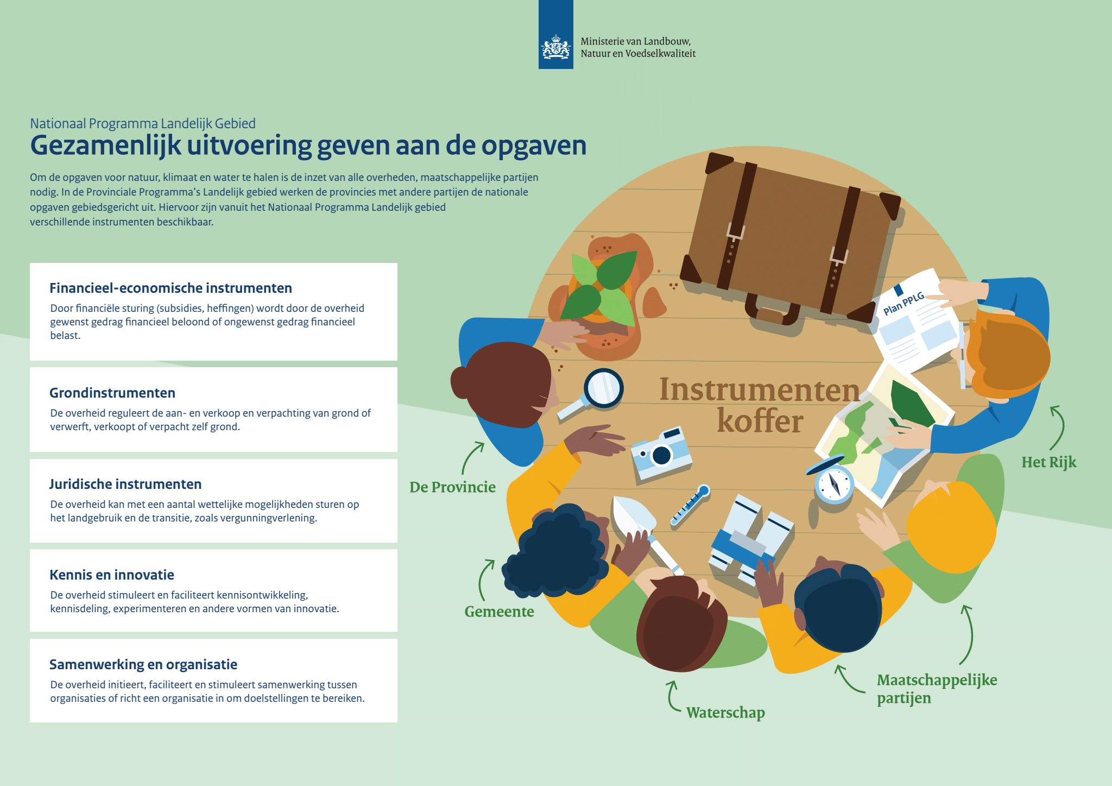

5. Realising the objectives together

The NPLG calls for a joint effort on the part of national and provincial authorities. Generic (national) measures and area-specific measures must combine to bring about the transition in rural areas. This will require careful harmonisation and agreements between national government and the provinces. The new Coordination Body for the Transition of Rural Areas will play a role in this process. A variety of instruments have been developed to help realise the objectives.

Agreements and cooperation between the various authorities
In order to achieve successful transition, smooth cooperation between the various levels of government will be needed. The provinces will be in charge of the area-specific approach. They will draw up provincial area programmes for rural areas (PPLGs) and the accompanying packages of measures in consultation with the water authorities, municipalities and national government agencies. In this inter-administrative cooperation, each participating government authority will contribute to the development and implementation of the area programmes and packages of measures, in line with their individual responsibilities. The code for Inter-administrative relations and collaboration agreements within the National Strategy on Spatial Planning and the Environment (NOVI) will be essential to meaningful cooperation. These specify among others that local and regional authorities must be involved in policy proposals, in time, and that the individual parties can call each other to account and cooperate on the basis of equal partnership.

Coordination Body for the Transition of Rural Areas (RTLG)
The transition is essential but also far-reaching, and places severe demands on the various stakeholders. With that in mind, a coordination body, established for this purpose – the Coordination Body for the Transition of Rural Areas – will assist the provinces, national government, the water authorities and the municipalities to achieve successful and effective implementation. The Coordination Body will support the practical implementation with a view to realising the NPLG objectives and will actively participate in the process of creating the NPLG, from the perspective of practical implementation. The Coordination Body will work to ensure that consistent and workable targets are formulated in the NPLG, on the basis of which the provinces can set to work in their area processes. It will also be the key link in solving problems relating to rules and policy, for example by encouraging the establishment of mutual agreements between the collaborating authorities, to improve the effectiveness of practical implementation.

Generic and area-specific instruments
The objectives of the NPLG can only be achieved through the combined efforts of all levels of government, civil society partners and sectors. The policy measures and instruments to be deployed in realising the transition are a combination of European, national, provincial and municipal government and water authority measures and instruments. Policy measures and instruments often distinguish between generic and area-specific. The NPLG explains how generic and area-specific measures can be deployed coherently by the various authorities.

Instrument case
Every level of government has its own role and instruments. In the provincial area programmes, the provinces elaborate the national tasks for nature, climate and water, specific to their area. That calls for instruments that can be locally deployed. The Draft NPLG contains an outline overview of the instruments that can be deployed in implementation of the provincial area programmes. This overview will be reproduced in greater detail in the form of the NPLG instrument case, that will describe the set of tools and instruments available at that moment. It will include a number of instruments that are not yet, but soon will be available (for example, the relocation scheme). Throughout the transition, more and more tools will be added to this instrument case, for example when an agriculture plan is published.

6. Participation and Strategic Environmental Assessment (SEA)
Participation is an important element of the NPLG. Numerous parties have already contributed their ideas to the NPLG and this has clearly sharpened and improved the content. The SEA also fulfilled a relevant role in sharpening the focus of the NPLG. By means of the SEA, the impact of the Draft NPLG has been examined, which has resulted in a number of changes to the programme.

Participation
The NPLG will impact rural areas in many different ways. Against that background, national government recognises the importance of calling upon representatives of society as a whole to submit their ideas, and to include those ideas in evaluating the policy. It also understands how important it is to inform all stakeholders – such as civil society organisations and the general public – carefully and transparently, and to involve them in the drawing up of the NPLG. This includes space for the different positions, interests and perspectives that are present, as well as offering opportunities to share insights and ideas while taking account of the opportunities and concerns. It is also possible that certain aspects have been left out, require further explanation or elaboration or that points are identified that deserve additional attention during the implementation phase. All these can be important signals to be taken on board in further developing the NPLG.
The NPLG also includes a coherent area-specific approach in which local and regional authorities – municipalities, water authorities and provinces – play an important role in the implementation process. For that reason, they too have been carefully consulted about the programme. In this way, all these parties will work together to generate support for the content and process of the NPLG and to reinforce the transition of rural areas.

Strategic Environmental Assessment
A Strategic Environmental Assessment (SEA) was prepared for the NPLG. Within this assessment, the possible impact of the NPLG on the environment, in particular the impact on the physical environment, was examined from a broad perspective. For the examined indicators, the SEA shows the current situation, the trends and the bottlenecks already identified. For the indicators, the impact of the structuring choices is described with regard to the bottlenecks and the trends.
The study was carried out at both a strategic and an outline level, appropriate to the level of abstraction of the NPLG. Where policy choices have a more outline character, their impact has also been sketched out on that level. The Wheel of the Living Environment forms the basis for the impact assessment. The SEA is above all an elaboration of the upper half of the Wheel, since the objectives of the NPLG for nature, water, climate and green-blue networking are aimed particularly at protecting the physical environment. The impact assessment in the SEA is a qualitative assessment of the opportunities and risks, and where possible of the likely impacts. These impacts, opportunities and risks are then ‘scored’ on the basis of expert judgement, making use of already available information.

List of abbreviations
BBN Carbon capture in Trees, Forests and the Natural environment
EA Ecological Authority
NOVI National Strategy on Spatial Planning and the Environment
NPLG National Programme for Rural Areas
NRD Memorandum on Scope and Level of Detail
PBL Netherlands Environmental Assessment Agency
RIVM National Institute for Public Health and the Environment
RTLG Coordination Body for Realisation of the Transition of Rural Areas
SEA Strategic Environmental Assessment report
Transition Fund Transition Fund for Rural Areas and Nature
VHR Bird and Habitats Directive
WFD Water Framework Directive
WUR Wageningen University & Research

This summary accompanies the Draft
National Programme for Rural Areas and is published by:
the Netherlands Ministry of Agriculture, Nature and Food Quality (LNV)
the Ministry of Infrastructure and Water Management, and
the Ministry of the Interior and Kingdom Relations
November 2023 I Publication xxxxxxxx

